CHAPTER I

INTRODUCTION

Nowadays, computer technology has made significant contributions to the world, specifically in the healthcare industry. As computer technology in the world of healthcare evolves, technology continues to improve the overall quality of healthcare for patients and doctors around the world. The impact of computer technology in healthcare today help the patients to self-educate regarding on medical issues, searching for treatment options, finding and communicating with health professionals. The doctor can establish contact with patients, answer questions about their practices, launch public awareness campaigns, perform community outreach programs, consult experts from all over the world and access information on drugs, studies, etc. It also enables statistical documentation of large populations that can accurately predict medical health trends and response to outbreaks.

Currently, some health centers in the Philippines are using the manual process of providing health care services to the community. The old manual process can cause data loss and poor quality of service. Health centers can adapt the current automated system of the Department of Health (DOH) the one used in the hospital to help their patients efficiently and effectively. The automated system in the hospital has a function to manage patient records, improve some diagnostic and treatment technologies.

The study focuses on the implementation of Saint Ezekiel Moreno Healthcare System that to improve the quality of service. This system aims to provide an overall automated process of services offered by the health center to help patients. This system has a module of patient’s profile, patient health progress monitoring, patient scheduling medication and healthcare management. The recording of data shows the patient's status compose of patient personal information, health problems, and the health progress monitoring. The patient health progress monitoring provides the progress and treatment outcomes for all the patient status on their health which lists each patient starting treatment and monitors progress towards a cure. The system also can generate reports depending on the number of patients, statistical health trends, monthly or yearly and the number of patients cured. The system can print prescriptions for the doctor recommendation depends on the health status of the patients. The Saint Ezekiel Moreno Healthcare Management System can be a big help to the organization regarding capturing of data and generating of monthly reports.

1.1 Organizational Background

The Sisters Servants of Mary is a Religious Congregation founded by St. Maria Torres Acosta under the patronage of Our Lady under the title of Mary, Minister of the Sick. This group encompasses a worldwide ministry of care and compassion in 128 convents in 21 countries.

Here in the Philippines that they have three houses namely Lagonoy, Camarines Sur which is the first foundation and followed by their community and formation house at Quezon City. Last 30th of May 2010, they opened a new organization in Bacolod City with the request and assistance of the Order of Augustinian-Recollects (OAR). The primary purpose is to reopen the Saint Ezekiel Moreno Health Center and to realize the given mission as a Servants of Mary.

1.2 Organization Mission

The mission of Sisters Servants of Mary is to improve regular service and to foment a healthy state in the population with the healing and prevention, compromised with legal requirements of public health with the provision of an integrated sanitary service.

1.3 Organizational Unit Function Description

Saint Ezekiel Moreno Health Center is composed of three primary functions which are the following: patient profiling, services, and inventory functions. Each function has their process which builds the organization. These sub-functions include the patient registration, services offered by the organization as well as the inventory.

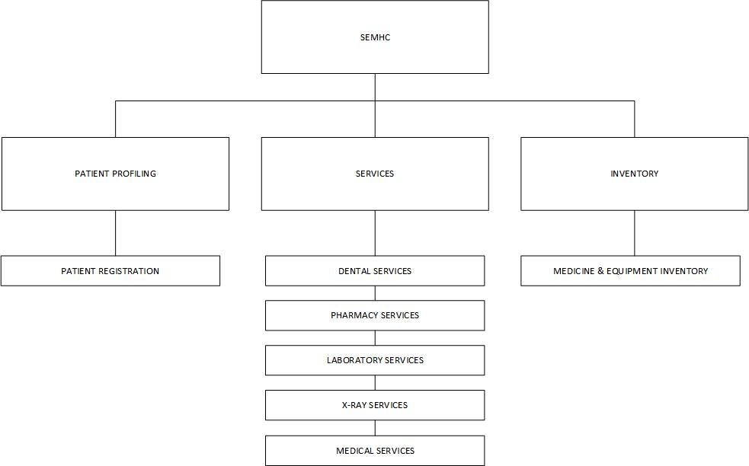

Figure 1. Organizational Chart of Saint Ezekiel Moreno Health Center.

1.3.1 Patient Profiling

This function focuses on the gathering of patient information to be registered in their current system so that the doctor can view the patients that are in need of a consultation regarding on their health issues. In this function, the patient’s progress is monitored through the history of diagnosis and treatments. Follow-up checkups are conducted if the patient is in need of further consultation. This function ensures that the patient can get the treatment that the organization can offer.

1.3.2 Services

This function is composed of several services which are the dental, pharmacy, laboratory and x-ray and medical services that the organization has offered to help with the patient’s health problems.

1.3.2.1 Dental Service

This service offers the patient treatment to their oral health problems to be checked by the dentist in the organization. This service is only available once a week every Tuesday.

1.3.2.2 Pharmacy Service

This service provides free medicine for the patient in the organization, and it receives payment from patients that require a laboratory service if the patient needs to be further examined regarding their health problems. If the patient cannot afford the required amount, the organization allow them to pay any price that they can afford.

1.3.2.3 Laboratory and X-ray Services

This service provides further study or examination of the patient health condition request by the doctor of the organization through the specimen samples (refer to figure 2 for specimen sample legend).

1.3.2.4 Medical Services

This service offers consultation, first aid and site visit which helps the patient who can’t afford to come to the health center. These services greatly benefit the patients who are in need of medical services.

1.3.3 Inventory Services

This service helps the organization check the available medicines left in their inventory. This service is valuable to the organization because it allows them to monitor some drugs to be ordered.

1.4 Current System Description

The Saint Ezekiel Moreno Healthcare Center has an automated system but is only implemented in one area: the registration. The current automated system has a statistical function but provides limited information due to uncertain data being shown to the user. The organization is composed of religious nuns and volunteers in aiding people. They provide services that include free checkup, home service if requested by the patient, laboratory tests and distribution of medicine after some follow-up check-ups. The patient is asked to proceed to the lab depending on his/her particular health condition, but the patient has to pay a certain amount of cash before conducting a laboratory study.

1.4.1 Patient Profiling

In this process, the patient, doctor, laboratory, and pharmacy is involved with one data store. The patient submits the patient information sheet to be encoded to the database for the physician to view the patient record.

1.4.2 Health Services

In this process, four entities are involved which is the physician, patient, laboratory, and pharmacy. Consultation is conducted as well the transaction for payment for lab study. Lab study requirements are also submitted for a lab study, and the compiled lab results are presented to the doctor for a follow-up check-up.

1.4.3 Inventory

In this process, two entities are involved which is the pharmacy and the supplier. The pharmacy confirms for the remaining number of medicine and sends a list of medication to the supplier for order.

Figure 2 shows there are five entities shown and each has its role. The entities are as follows: Patient, physician, pharmacist, supplier and the medical technologist. The patient submits his/her information during registration to be received by the doctor. The doctor takes action by having a consultation. After that, the patient goes to the pharmacy to pay extra fees. The patient then goes to the lab for the requirement of submitting specimen samples. After sending the samples, the patients wait for the results and proceeds to the pharmacy for the medicine. The pharmacy then orders medicine from the supplier if their medicine stock is insufficient. The pharmacy provides the supplier the list of medication needed to be ordered. As of now, the organization doesn’t monitor their medication during distribution.

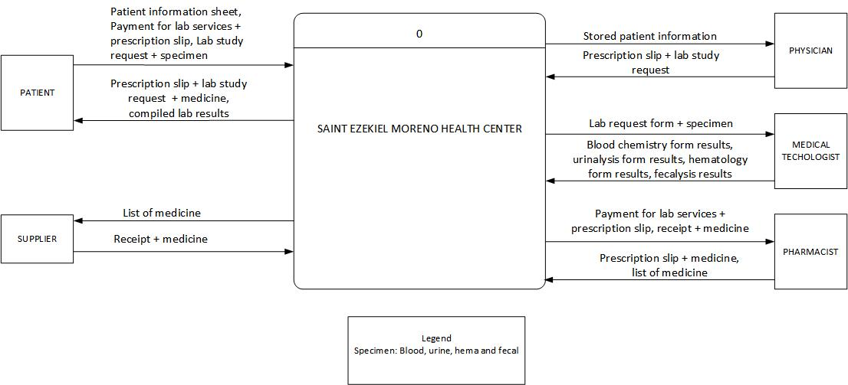

Figure 2. Context Diagram of Saint Ezekiel Moreno Health Center.

The second explosion of the first process has two sub processes which is encode patient information and view patient health information. The staff encodes the patient information to be stored in the database so the doctor can see it from his/her computer. The doctor then collects the health history, vital signs and chief complaints from the patient information.

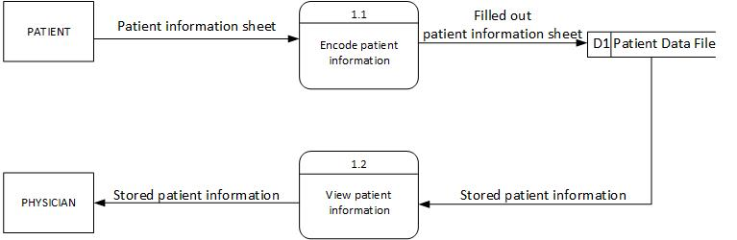

Figure 3. Second Explosion of the Patient Profiling of St. Ezekiel Moreno Health Center.

The second explosion of the second process has six sub-processes and four entities. This diagram shows the health service of the organization which includes the doctor providing a prescription slip with a lab study request. The patient proceeds to the pharmacy to pay for the lab services as well as getting the medicine basing on the prescription slip. The patient continues to the laboratory to submit the requirements needed for the lab study. The lab processes the submitted specimen and the results are compiled and released to the patient. The collected lab results are then acquired by the patient to be shown to the doctor in the follow-up checkup.

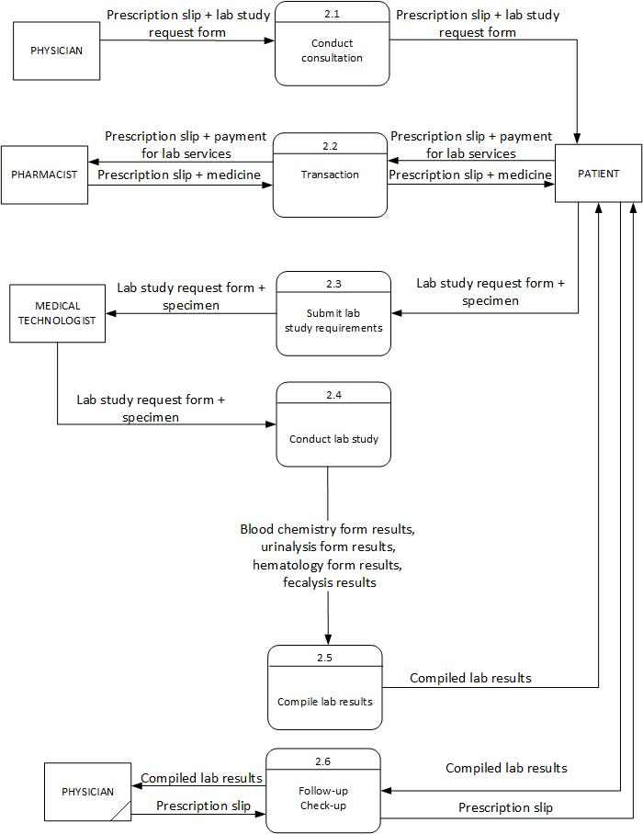

Figure 4. Second Explosion of the Health Services of St. Ezekiel Moreno Health Center.

After periods of distributing of medicine, the organization makes a medicine count to ensure the health center has a sufficient supply of medicine. In this process, the pharmacy checks if enough medicines are remaining. If the number of medicine is low, the pharmacy should have to order from their supplier for extra supplies of medicine. The pharmacy only monitors the acquisition of medicine.

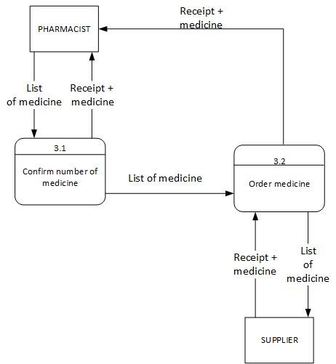

Figure 5. Second Explosion of the Inventory of St. Ezekiel Moreno Health Center.

Figure six shows the system diagram of the organization which shows the combined process from process one to three. These methods are shown previously in the major operations (refer to figure 1). The first process is the patient profiling which mostly focuses on acquiring of patient information. The second process is the health services which focus on the health diagnosis of the patient. Lastly, the inventory which focuses on the monitoring of incoming medicine in the organization. Medicines are monitored after acquiring the ordered products.

In general, this chapter discusses the current flow of the organization. This section includes the organizational background, organizational mission, unit description, current system description and the context diagrams followed by the second explosion (refer to Figures 3, 4 and 5) and the system diagram (see Figure 6).